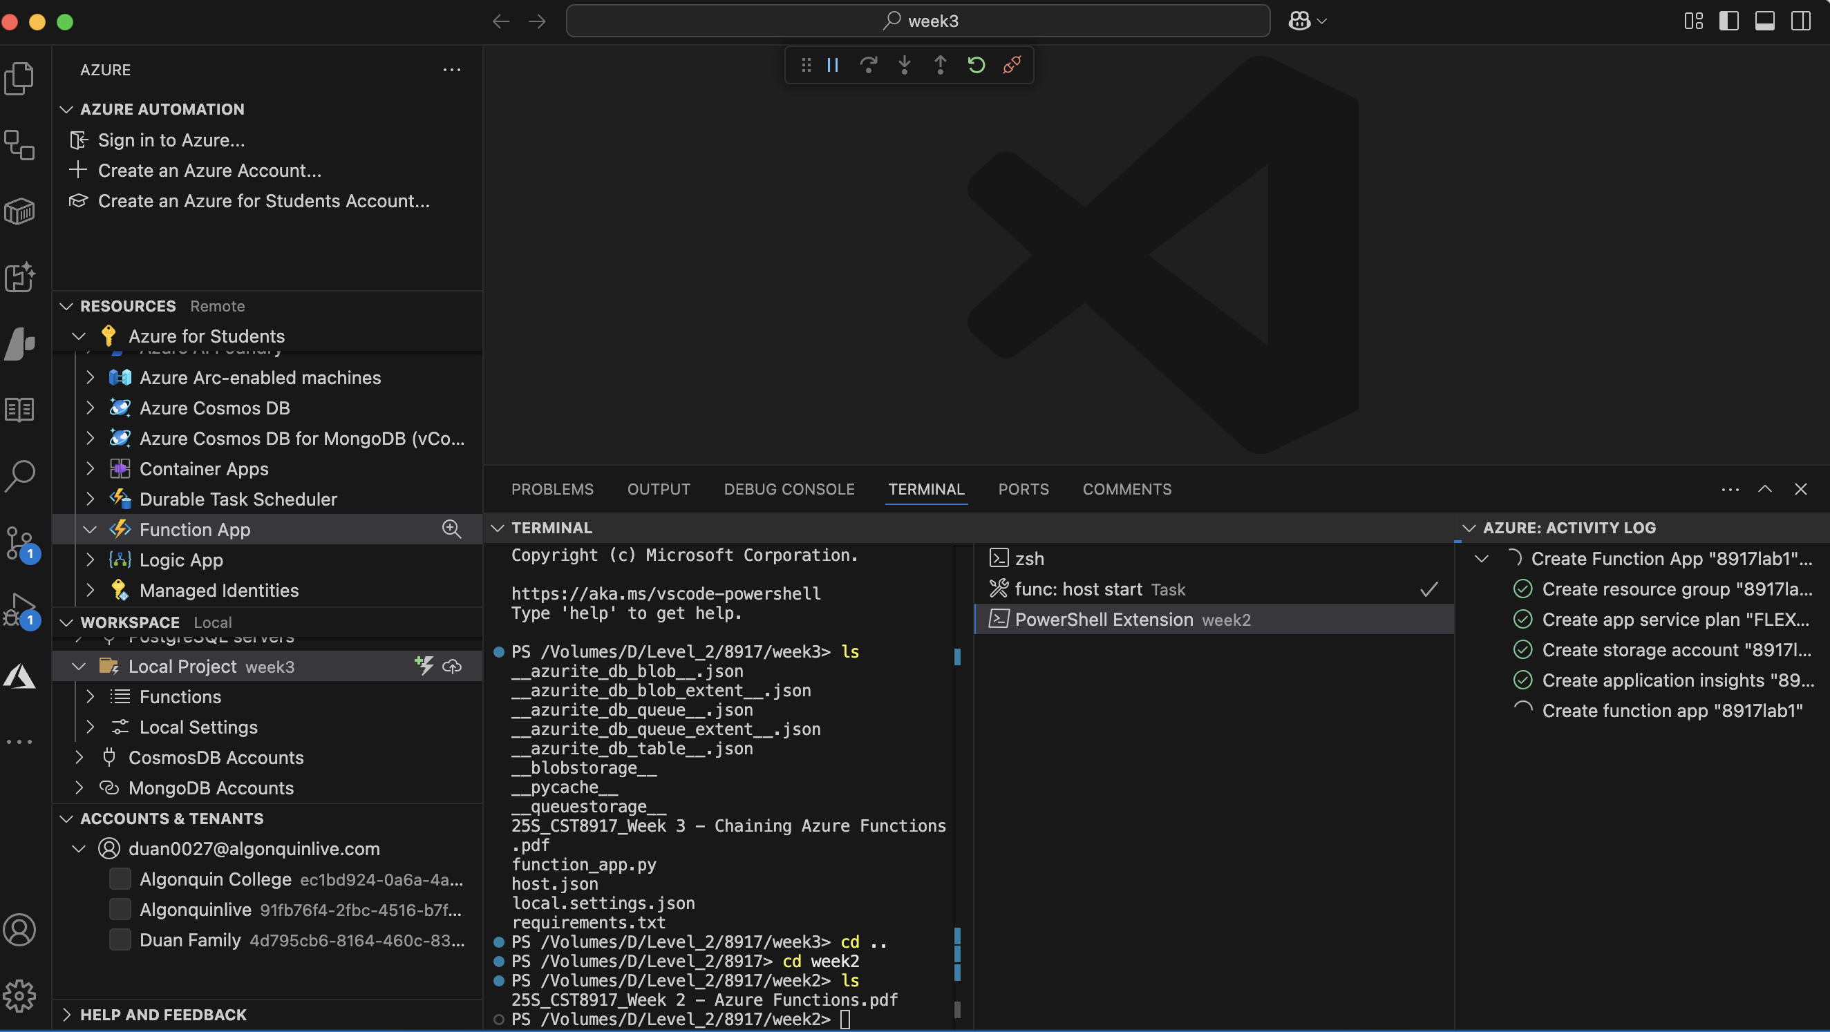

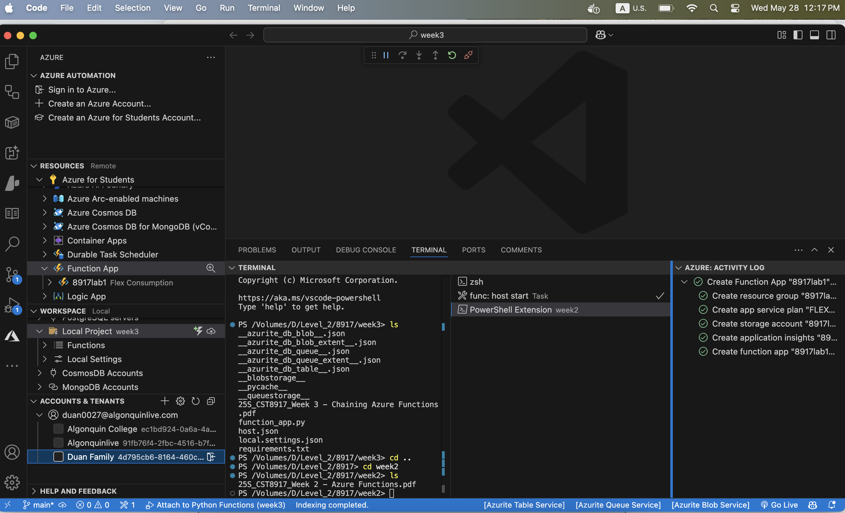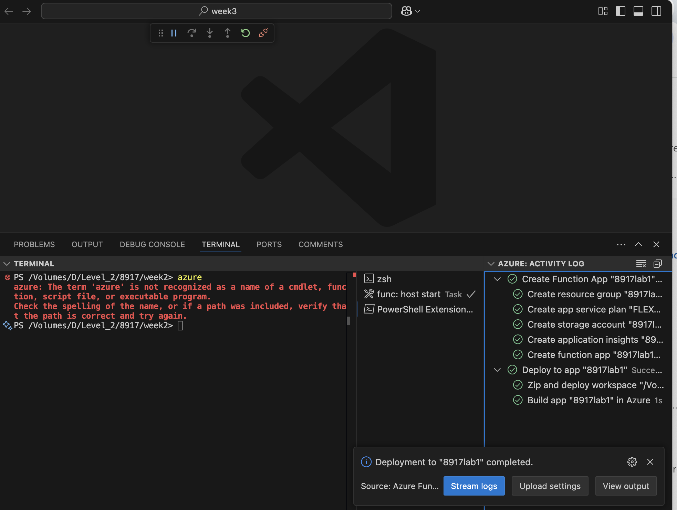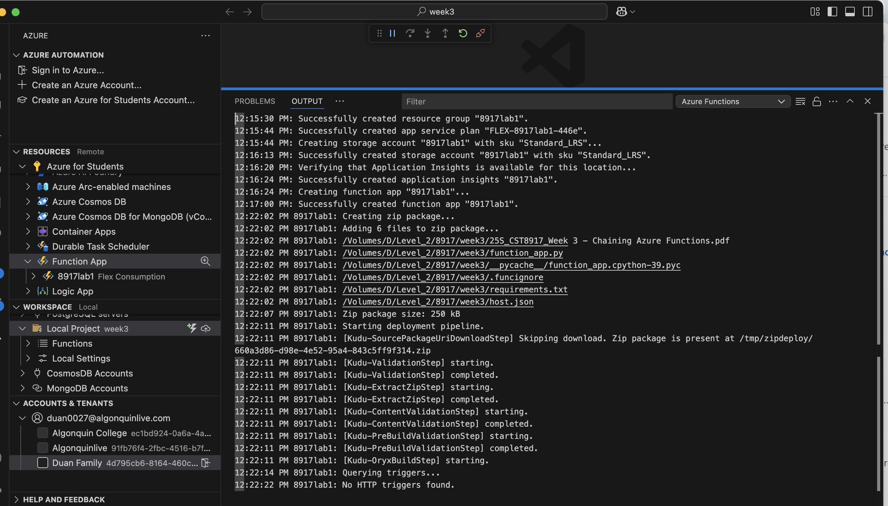

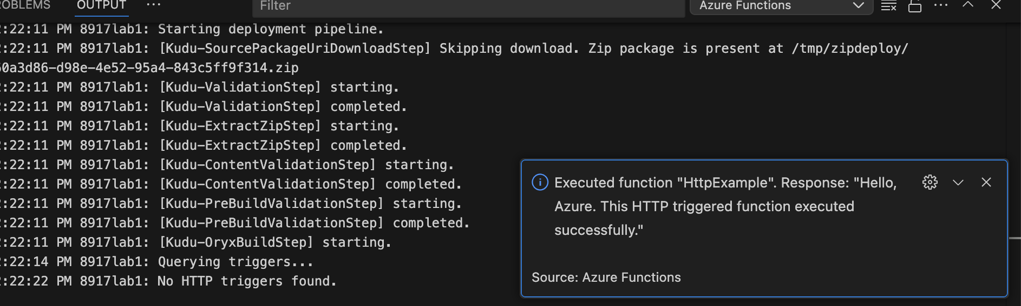

SQL Connection strings：

Server=tcp:shaoxian.database.windows.net,1433;Initial Catalog=mySampleDatabase;Persist Security Info=False;User ID=azureuser;Password=Password_1234;MultipleActiveResultSets=False;Encrypt=True;TrustServerCertificate=False;Connection Timeout=30;

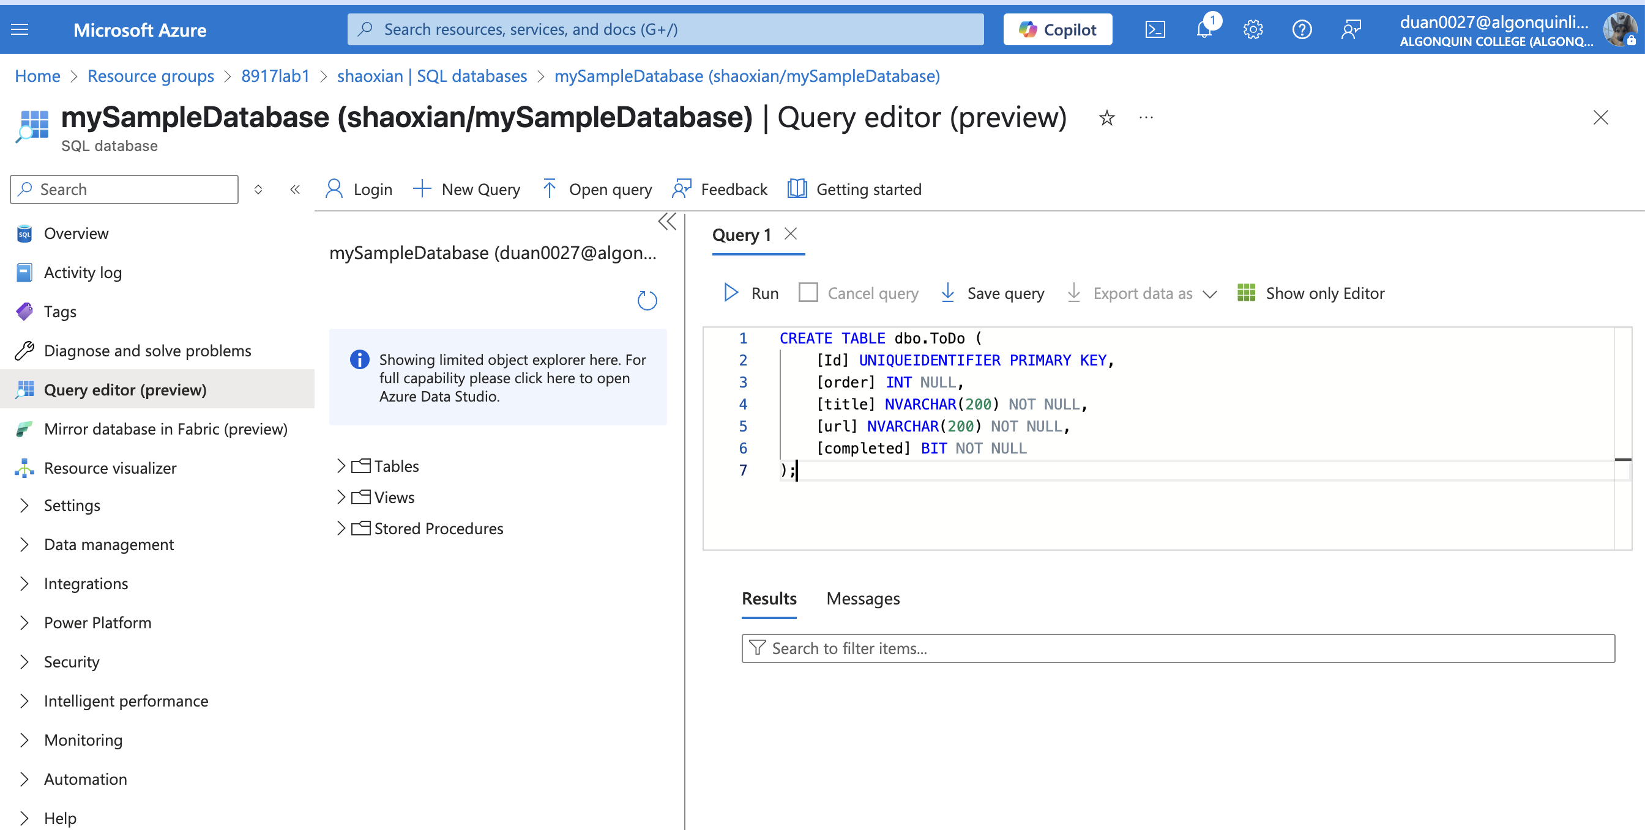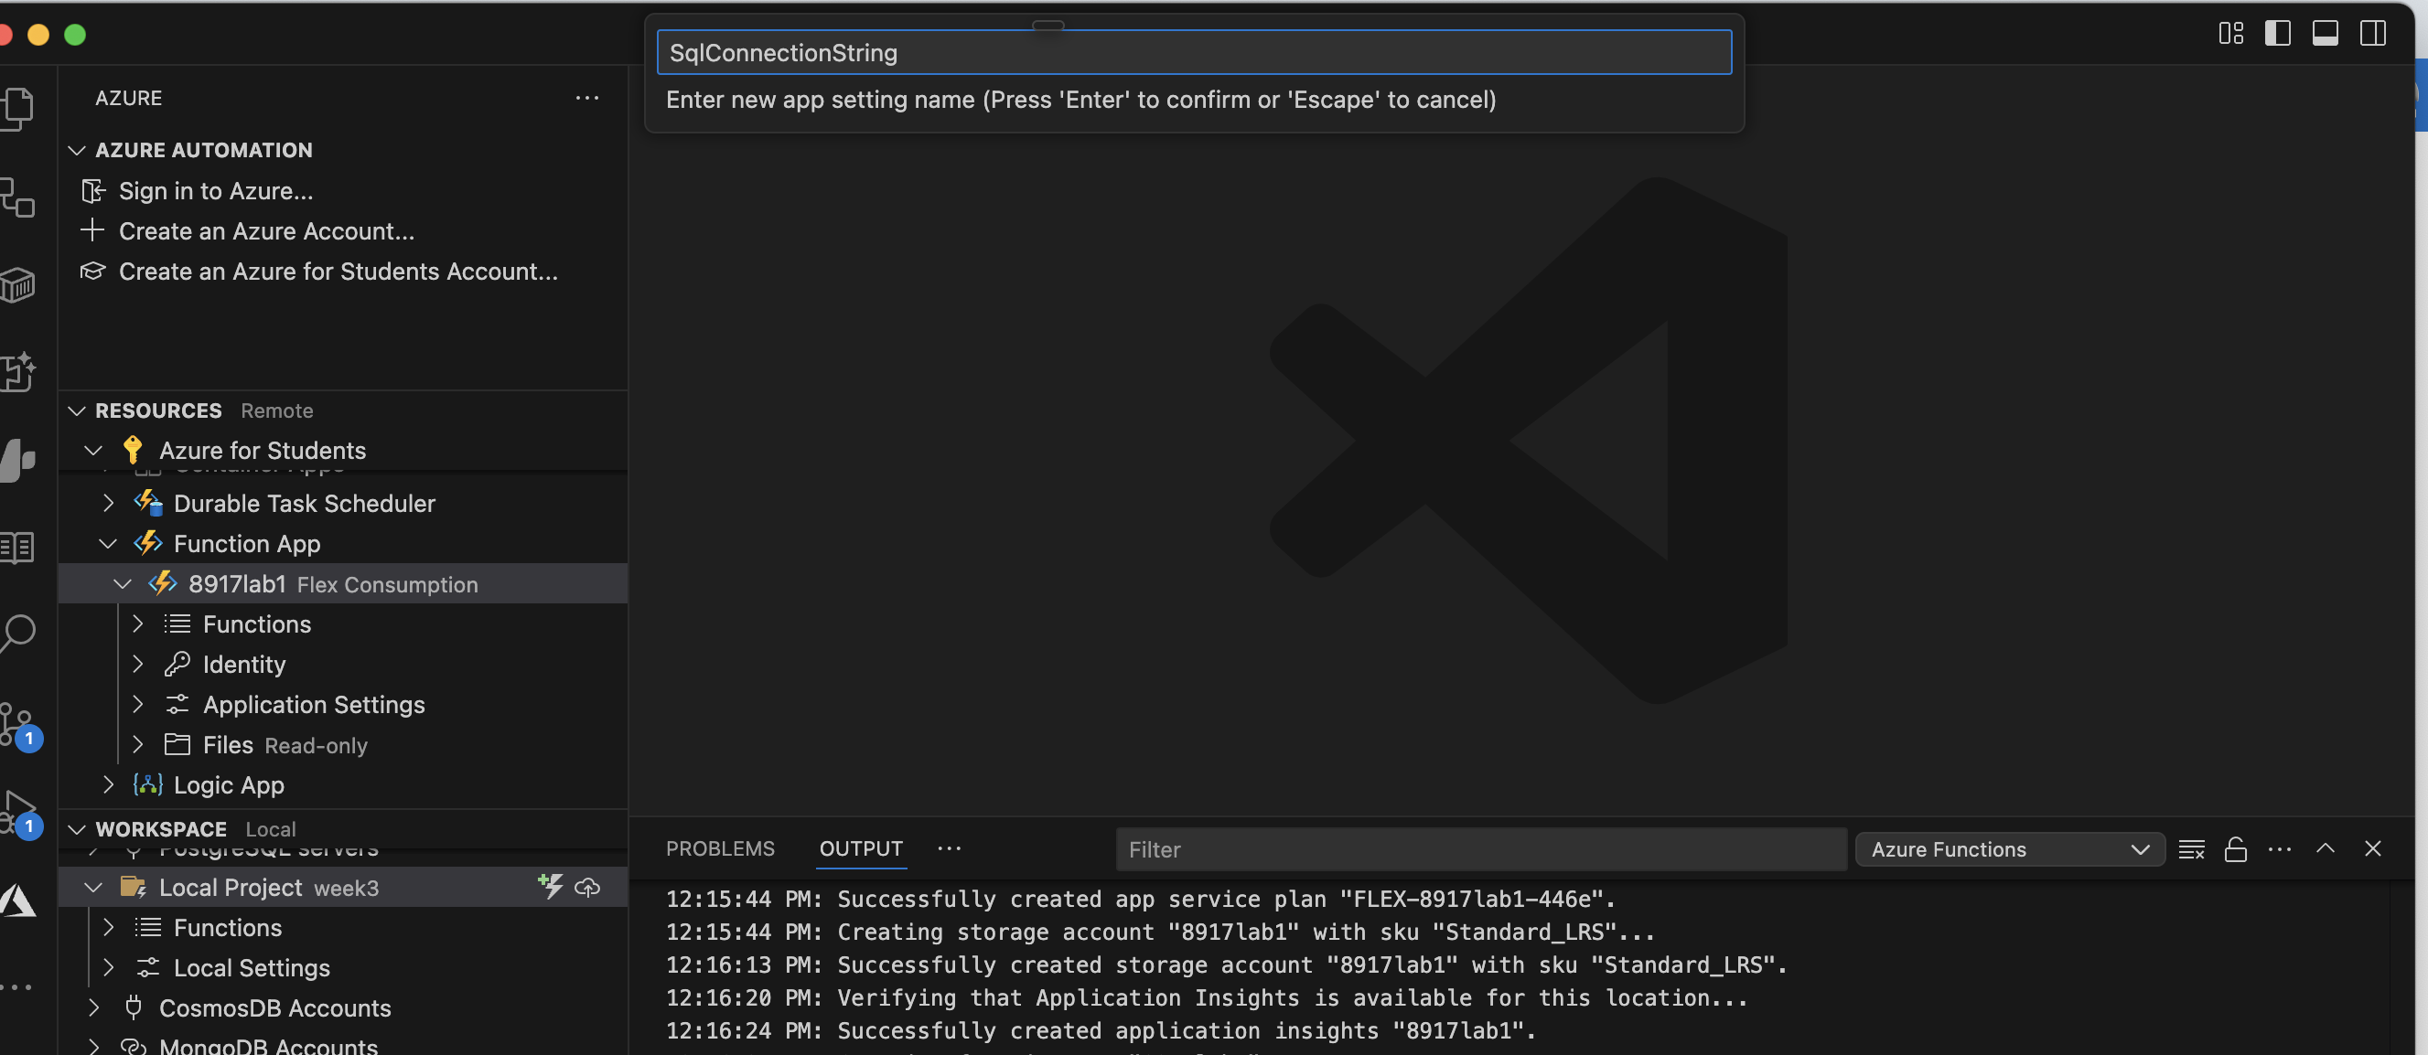

Azure Functions: Download Remote Settings....

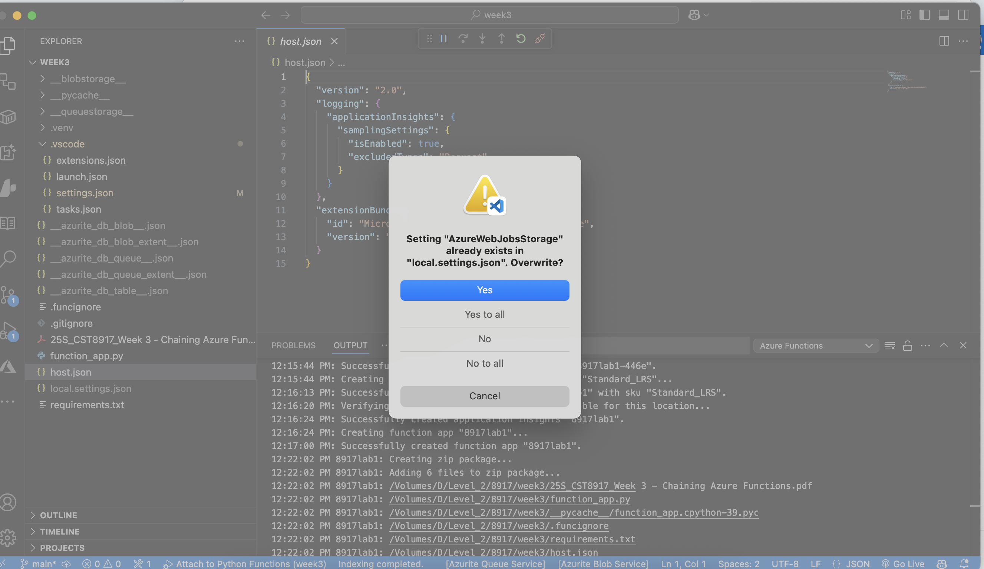

Redeploy function on azure:

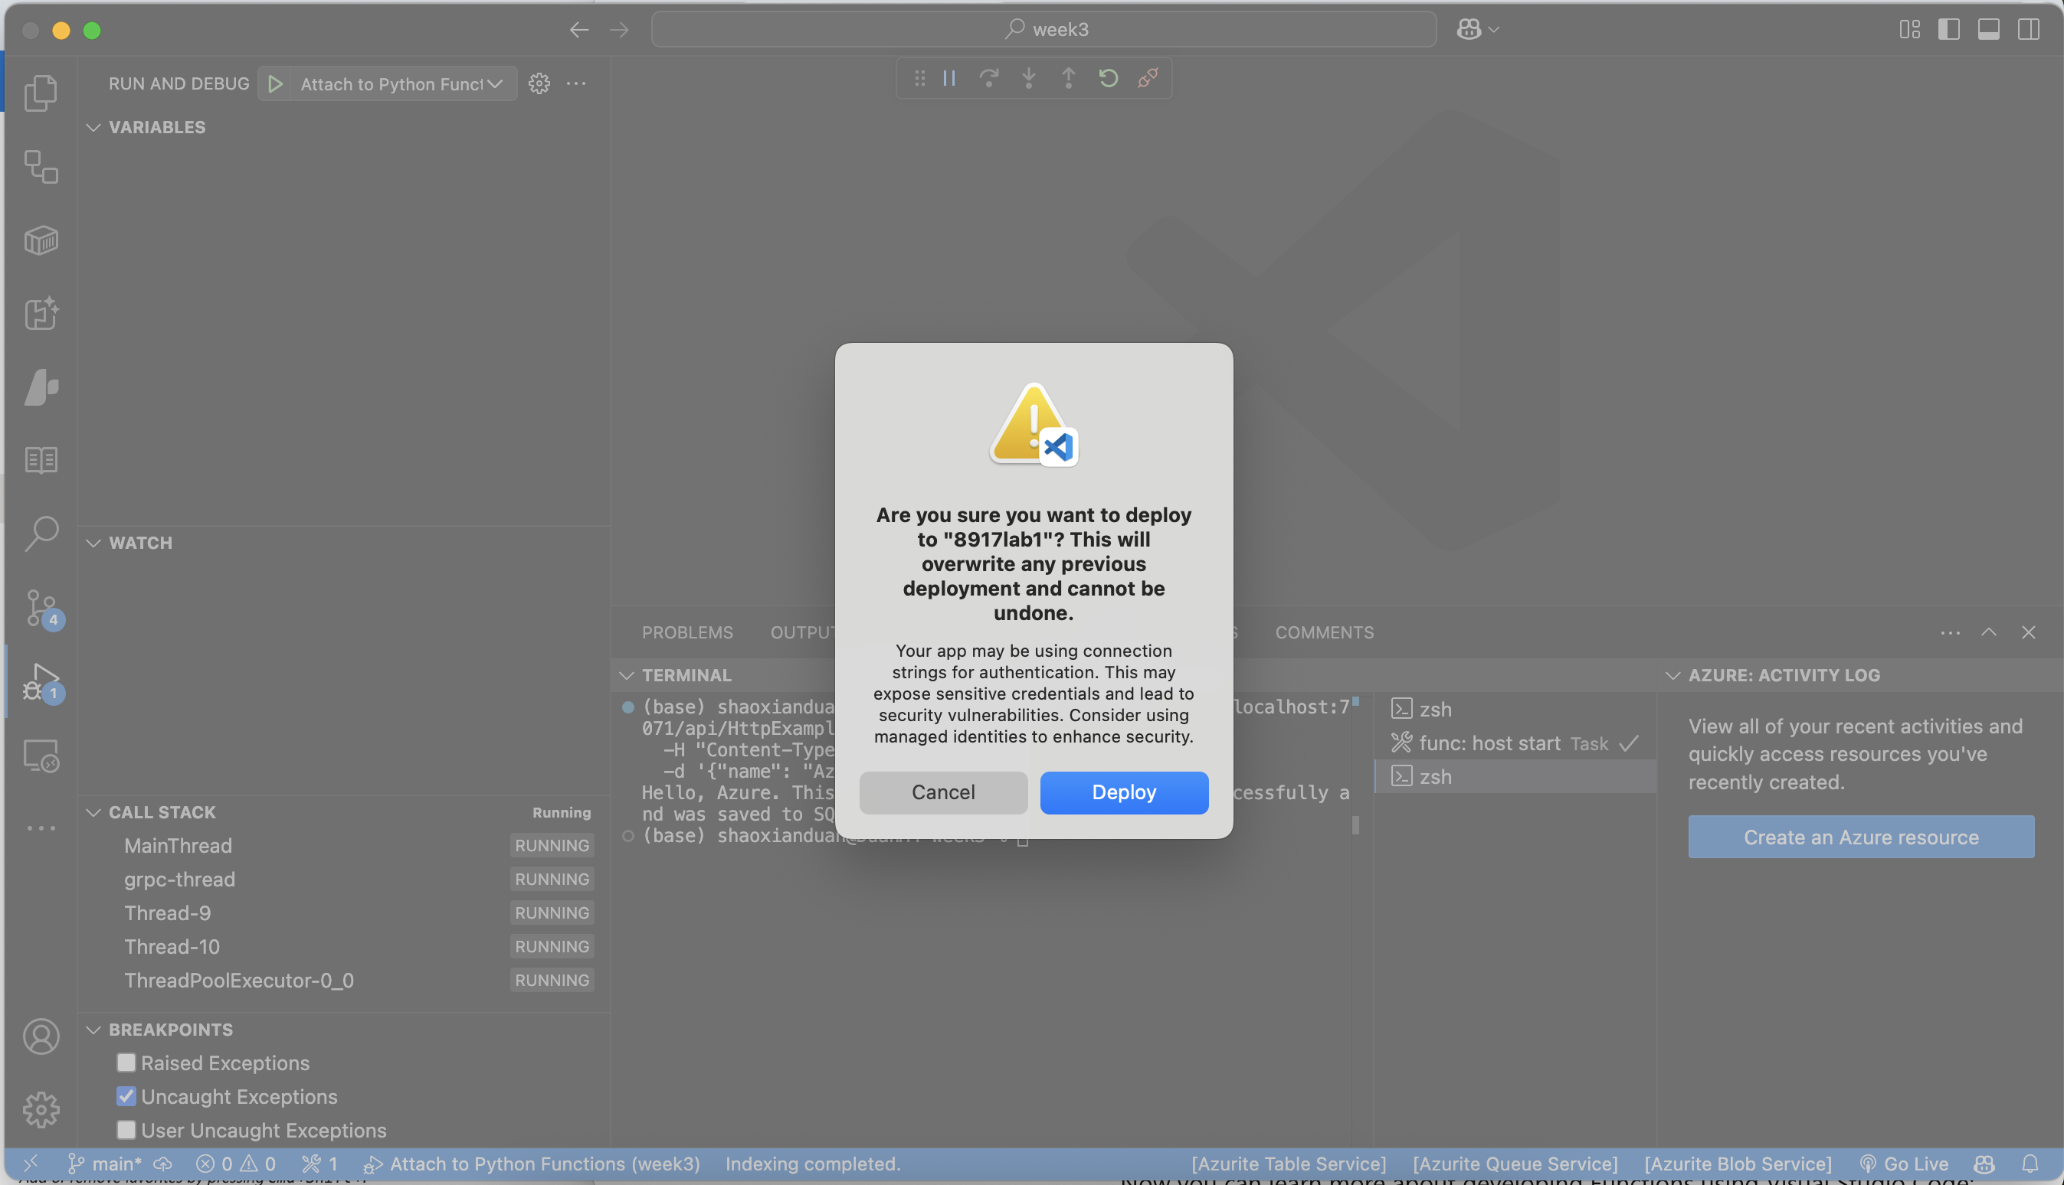

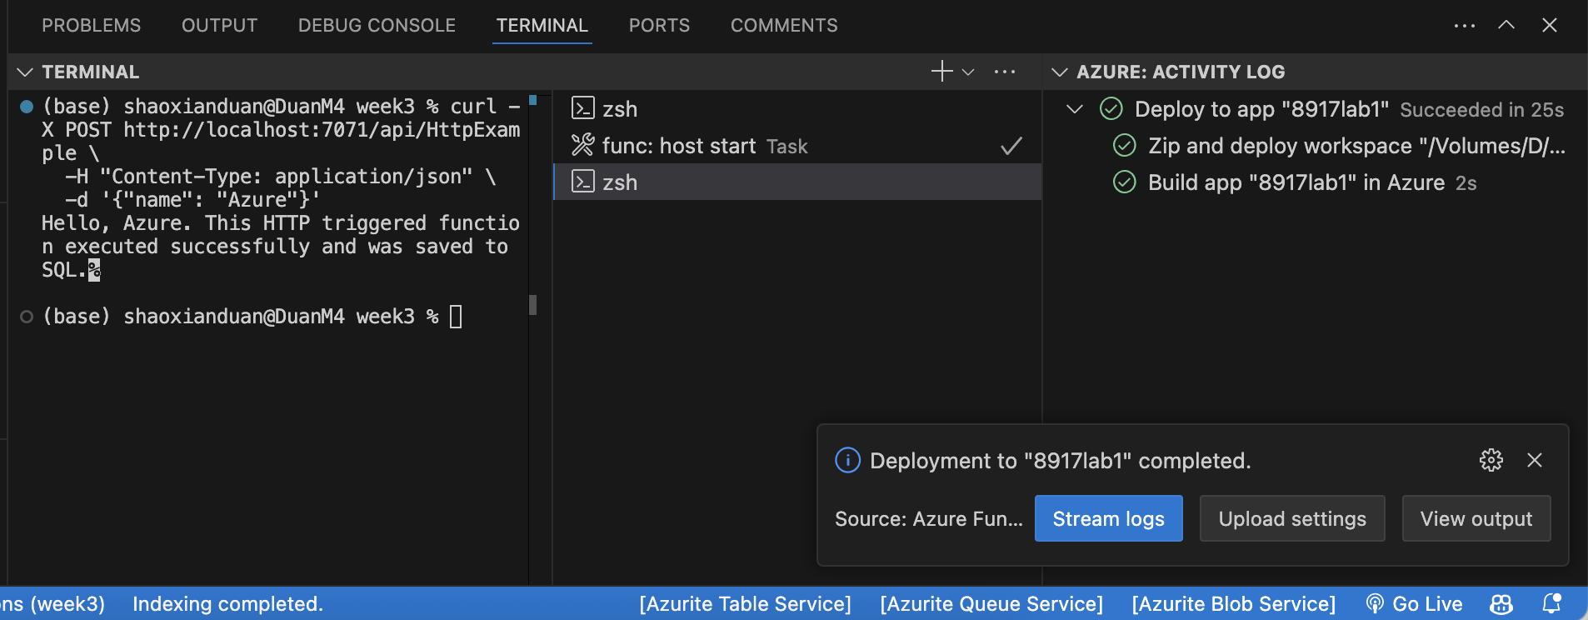

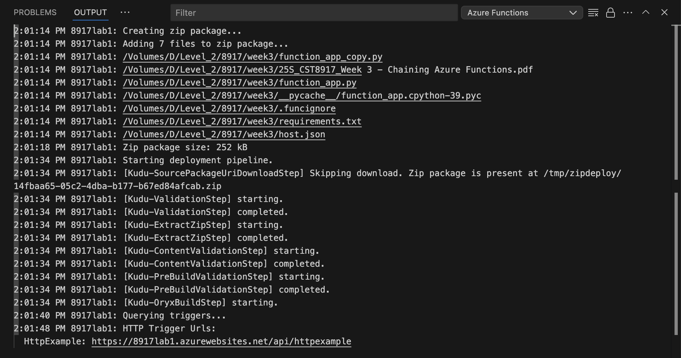

**Verify：<https://8917lab1.azurewebsites.net/api/httpexample>**

**https://8917lab1.azurewebsites.net/api/httpexample**

**curl -X POST** [**https://8917lab1.azurewebsites.net/api/httpexample**](https://8917lab1.azurewebsites.net/api/httpexample)**\**

**-H "Content-Type: application/json" \**

**-d '{"name": "Test Screen Record"}'**

SELECT TOP 10 * FROM dbo.ToDo ORDER BY Id DESC;